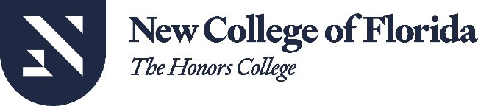

Office of Chief Audit Executive and Chief Compliance Officer

Date: September 17, 2025

To: Richard Corcoran, President
New College of Florida
Sent via email to rcorcoran@ncf.edu

From: Alexander G. Tzoumas, Chief Audit Executive and
Chief Compliance Officer
New College of Florida

Subject: State University System Board of Governors
Foreign Gift Reporting Inspection, FY 2024-2025

Dear President Corcoran,
On September 16, 2025, the Office of Internal Audit and Compliance received a notice of inspection from the State University System Office of the Inspector General and Director of Compliance (OIGC) for the Board of Governors. The OIGC requested for additional documentation to support the New College of Florida’s (University) Foreign Gifts and Contract report filed with the Board of Governors as required pursuant to Florida Statute 1010.25, Foreign Gift Reporting. The purpose of the inspection was to determine compliance with the statutory reporting requirements. As part of the inspection, the OIGC validates whether the reported information was complete and accurate by comparing the information in our Foreign Gifts and Contracts Report and the information contained in the supporting documentation uploaded to the Board of Governors Information Request System.
In accordance with the OIGC request, the Office of Internal Audit and Compliance and Office of Research Programs and Services provided the additional documentation requested by the OIGC to complete their inspection. The OIGC reported that the additional documentation provided adequately supported the University’s Foreign Gift and Contracts Report. As such, the inspection was successfully satisfied.
I would like to recognize the timely and complete response provided by Elizabeth Bright and her team in the Office of Research Programs and Services. Ms. Bright has continually been a strong supporter of regulatory compliance efforts and performed her compliance work in an exemplary manner.
Kind regards,

cc: Rob Zamsky, Associate Provost
Sent via email to: rzamsky@ncf.edu

