FINAL DRAFT
NOTICE OF PROPOSED REGULATION AMENDMENT
New College Board of Trustees
REGULATION CHAPTER NUMBER
Chapter 3-Administrative Affairs
REGULATION NUMBER AND TITLE
Chapter 3-1002 (6) Tuition and Fee Schedule

SUMMARY OF PROPOSED REGULATION AMENDMENT
The proposed amendment is to Regulation 3-1002 (6) which specifies the prices for meal plans.
The proposed price increases will allow the College to enhance dining services and continue to operate on a financially sustainable basis while maintaining the lowest-cost meal plan in the State University System of Florida.

NEW COLLEGE OFFICIAL(S) INITIATING THE REGULATION AMENDMENT
Chris Kinsley, Vice President for Finance and Administration

PRECEDURE FOR COMMENTING ON PROPOSED REGULATION AMENDMENT
Comments may be submitted as follows:
- Any person may submit comments concerning the proposed regulation amendment at any time up to 14 days prior to April 26, 2023. Comments can be provided by mail, fax, email, or telephone at:

Bill Galvano
New College of Florida
5800 Bay Shore Road Sarasota, FL 34243
Phone: (941) 487-4877
Email: bgalvano@ncf.edu

Comments will be presented to the Board of Trustees for consideration.
2. Comments may also be directed in person to the Board of Trustees at its meeting scheduled for April 26, 2023. The meeting will begin at 2:00 P.M at the Harry Sudakoff Conference Center.

ACTION BY NEW COLLEGE BOARD OF TRUSTEES
The New College Board of Trustees will consider the proposed regulation amendment for adoption at its regular meeting as follows:
Date: April 26, 2023
Time: 2:00 p.m.
Location: Harry Sudakoff Conference Center
New College of Florida 5845 General Dougher Place Sarasota FL 34243

EXISTING REGULATION LANGUAGE

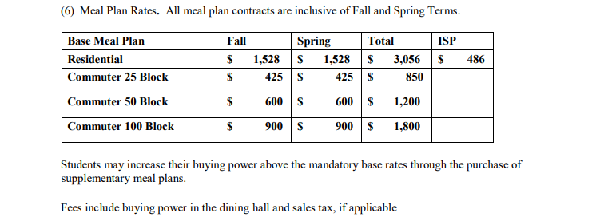

TEXT OF PROPOSED REGULATION AMENDMENT
The full text of the proposed regulation amendment is set out following this notice.
Strikethrough indicates deletion; Underline indicates addition.
3-1002 (6)

3-1002 (6) Tuition and Fees Schedule (Strike All Existing, and Replace with)

(6) Meal Plan Rates

The per term Meal Plan Rate for 2023/2024 for residential students shall be $1,910, with the ISP term rate being $608. Off campus students are required to purchase either 1) A Commuter Meal Plan or the 2) A Residential Meal Plan. The ISP Meal Plan optional for commuter students.

The President is authorized to approve all meal plan alternative rates, including commuter plans, the stand-alone ISP meal plan rate, employee plans, and visitor plans.

