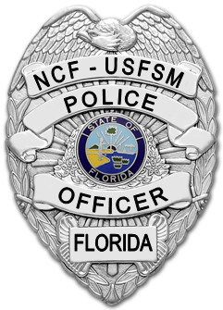
What To Do If You’re Stopped By Police

There are many reasons why you might be stopped by a law enforcement officer. Whatever the reason, your cooperation is important and can reduce potential conflict. Officers have a duty to investigate matters involving public safety and/or criminal acts.
Common reasons include:
- Traffic violations
- Suspicious behavior
- Your vehicle may match the description of a wanted vehicle.
- You may match the description of a witness, suspect, or victim.
- The officer may believe you need help.
- The officer may want to warn you about a potentially dangerous situation.
Questions are not accusations. Being stopped by the police can be a stressful experience and you may feel anxious, confused, or angry. Here are some helpful tips:
- Stay calm and courteous.
- Comply with instructions.
- Don’t run, resist, or obstruct the officer.
- Do not lie or provide false documents.
- Keep your hands visible and do not make any sudden movements.
- Tell the officer if you have a weapon and its location. Do NOT touch the weapon.
Every situation is unique. When police have a reasonable suspicion to believe a crime has been committed, is being committed, or is about to be committed, you may be temporarily detained and must present identification. The officer may detain you long enough to investigate the
situation. If probable cause exists, an arrest may be made. After an inquiry into the circumstances, if no probable cause exists for arrest, you shall be released. Upon request, police should provide their name and the reason for the stop.

After the encounter, if you have questions about procedures or believe your rights have been violated, write down everything you remember including the name of the officer and agency, the date, time, and location, etc. If you were injured, seek prompt medical attention and take photographs. Obtain contact information for any witnesses. To report the incident, call and request to speak with a police supervisor or file a written complaint or complete a police service survey online at www.ncf.edu/police/forms

